# Virtual Key for your Repositories

## (Specification document)

Note – The following document includes

1. Project and developer details
2. Sprints used
3. Algorithm
4. Flowchart
5. Core Concepts used in developing the project
6. Project link (GitHub repository link)

PROJECT AND DEVELOPER DETAILS –

The following program is created for managing files. Listing of the files from the directory. Creating, deleting and searching operations can be performed by this JAVA program.

This program is developed by Syed Naseem Sharif .

SPRINTs –

1st sprint – Main function was created. Welcome screen printing the company name developer name and printed the 3 options. Switch statements were added to call the other classes based on the user input. Calling the function was tested.

2nd sprint – The remaining classes were created and the functionality was coded.

3rd sprint – The Program was tested by giving all the possible values and necessary changes were made based on the errors.

4th sprint – The final program is ready and working.

ALGORITHM –

Main Function

Step 1 – Printed welcome screen with company name, developer name and printed the 3 options for the user to select from.

Step 2 – Initialized directory.

Step 3 -Used Switch Statement to select the option based on user input.

Step 4 – Called the other classes under the preferred selections.

Step 5 – exit function defined under the switch statement.

Step 6 – Main function Completed.

ListFile Class

Step 1 – created a class listFile

Step 2 – Used String array to list the contents of the directory

Step 3 -Used if loop to print the contents incrementally based on the length of the array.

Step 4 – List Function completed

File handling Class

Step 1 – created a class fileHandling

Step 2 – used while loop to repeat the options until the go back to main menu option is selected.

Step 3 – Printed 4 options, to create, delete, search and go back to main.

Step 4 – used switch statement to select the operation based on user input.

Step 5 – called each function under the case statements of switch. And go back to main menu option provided in the switch statement.

Step 6 – created 3 functions create, delete and search

Step 7 – Define each function with the File operations in java.

Step 8 – for createFile() function we used file.createNewFile() method and also checked if it already existed in the directory and created a new file only if the file was not existing.

Step 9 -for deleteFile() function we used file.delete() method to delete the files and also only deleted if the file exists or else displayed file does not exist.

Flow Chart–

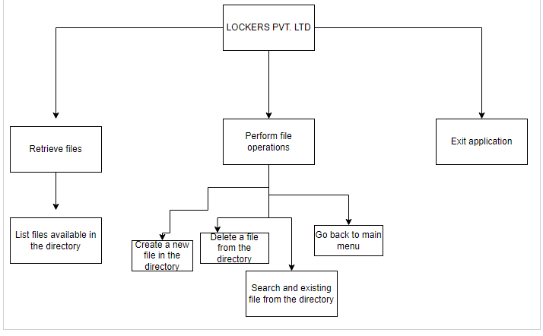

CORE CONCEPTS USED –

1. Switch statement
2. String Array
3. List collections
4. File function in JAVA
5. Different classes used

GitHub link (project link) -

https://github.com/SyedNaseemSharif/ssharif